**TIME SERIES ANALYSIS FOR ENERGY DEMAND FORECASTING**

**By**

**SHAMLA KANNACHETH**

Submitted to

**The University of Roehampton**

In partial fulfilment of the requirements

for the degree of

**MASTER OF SCIENCE IN COMPUTING**

Abstract

Time series analysis is a significant device used to conjecture energy interest by dissecting information designs over the long haul. Time series examination is a measurable strategy used to dissect and estimate information that is seen throughout some stretch of time, in a consecutive way. It is broadly applied in different areas, including finance, financial aspects, environment demonstrating, and energy request estimating. The primary aim of this project is to implement time series analysis for energy demand forecasting which can detect the required amount of energy by any organization. ARIMA model the Autoregressive moving average integration process is the method applying which the time forecasting is generally done. Exceptions or atypical information focuses can adversely affect the exactness of the conjecture. Time series analysis provides the crucial part in energy demand forecasting. Its capacity to catch and investigate verifiable examples empowers partners to successfully go with informed choices and plan for what's in store.

Signed

Declaration

I hereby certify that this report constitutes my own work, that where the language of others is used, quotation marks so indicate, and that appropriate credit is given where I have used the language, ideas, expressions, or writings of others.

I declare that this report describes the original work that has not been previously presented for the award of any other degree of any other institution.

**Date:** 06/09/2023

**Enter your name here: SHAMLA KANNACHETH**

Acknowledgements

The work would not have been possible without the contribution of my project supervisor Dr. Mohammed F Khan of the University of Roehampton. I am indebted to Dr. Lisa Haskel and Dr. Charles Clarke who have offered continuous support while preparing the project. I am also grateful to all those with whom I had the opportunity to do the work and complete the project. Each member of the dissertation committee have offered and provided professional guidance and have given me great advice while completing the project. On a personal note, I am also grateful to my family members who have offered me continuous support while I was completing the project. Without their help and support of them, this project would not have been completed

**TABLE OF CONTENTS**

Chapter 1. Introduction 9

1.1 Introduction 9

1.2 Research background 9

1.3 Research Aim 10

1.4 Research objective 10

1.5 Research question 11

1.6 Research rationale 11

1.7 Research Significance 11

1.8 Research Framework 12

1.9 Conclusion 12

Chapter 2: Literature Review 13

2.1 Introduction 13

2.2 Empirical study 13

2.3 Theories and Models 20

2.4 Literature Gap 21

2.5 Conceptual Framework 22

2.6 Conclusion 22

Chapter 3: Methodology 24

3.1 Introduction 24

3.2 Method Outline 24

3.3 Research Philosophy 25

3.4 Research Approach 25

3.5 Research Design 25

3.6 Research Strategy 26

3.7 Data Collection Method 26

3.8 Data Analysis 26

3.9 Research Limitations 27

3.10 Time Horizon 27

3.11 Conclusion 27

Chapter 4: Implementation 28

4.1 Introduction 28

4.2 Analysis 28

4.3 Conclusion 36

Chapter 5: Result 37

Chapter 6. Conclusion 52

6.1 Introduction 52

6.2 Linking with Objectives 52

6.3 Future scope 53

6.4 Recommendation 54

6.5 Conclusion 55

Reference List 56

Appendices 60

# **Introduction**

## **1.1 Introduction**

Time series analysis is a significant device used to conjecture energy interest by dissecting information designs over the long haul. As energy utilization keeps on expanding, precise anticipating is significant for effective asset designation and arranging. By concentrating on authentic time series information and recognizing patterns, irregularity, and different examples, investigators can make informed expectations about future energy interest. This examination helps service organizations, policymakers, and energy makers to expect likely market interest awkward nature, alleviate gambles, and guarantee dependable energy supply. Through determining, partners can allot assets really, enhance energy creation, and execute measures for practical and proficient energy the board.

## **1.2 Research background**

Time series examination is a measurable strategy used to dissect and estimate information that is seen throughout some stretch of time, in a consecutive way. It is broadly applied in different areas, including finance, financial aspects, environment demonstrating, and energy request estimating. Energy request forecasting assumes an essential part in arranging and decision-production for power age, dissemination, and valuing. One of the critical difficulties in energy demand forecasting is the exceptionally powerful and nonlinear nature of energy utilization designs. Energy demand is impacted by a few elements, like weather patterns, financial pointers, and mechanical progressions. Time series investigation gives a strong system to catch and dissect the fleeting conditions and examples inside energy request information.

The most important phase in time series examination for energy demand determining includes pre-processing the crude information, which incorporates taking care of missing qualities, exceptions, and performing information standardization. The subsequent stage is to grasp the fundamental numerical portrayal of the information. This is normally finished by breaking down the time series into pattern, occasional, and remaining parts utilizing methods like moving midpoints, outstanding smoothing, or occasional deterioration of time series (STL). The pattern part catches the drawn out changes or development in energy interest, while the occasional part addresses the common examples over a particular period, like every day, week by week, or month to month variances. When the time series parts are distinguished, different gauging procedures can be applied. These procedures range from straightforward factual models like autoregressive integrated moving average (ARIMA), to more modern AI calculations, like brain organizations, support vector relapse, or arbitrary timberlands.

To assess the estimate execution, different measurements can be utilized, including mean absolute percentage error (MAPE), mean absolute error (MAE), root mean squared error (RMSE), or the relationship coefficient. These measurements give quantitative proportions of the precision and dependability of the estimated values. Time series examination for energy request determining gives important experiences into the verifiable examples and future patterns of energy utilization. It helps energy suppliers and policymakers to go with informed choices connected with asset assignment, energy productivity, framework arranging, and sustainable power coordination.

## **1.3 Research Aim**

* To develop an accurate time series forecasting model for energy demand, enabling reliable predictions for future energy consumption.
* To optimize resource allocation by providing accurate forecasts of energy demand, assisting in efficient power generation, distribution, and infrastructure planning.
* To enhance demand management and load balancing strategies by analysing historical energy demand data and developing methods to regulate and influence demand patterns effectively.

## **1.4 Research objective**

* To develop imaginative time series analysis models and methods that can successfully catch and break down complex worldly examples in energy demand forecast.
* To expand the precision and unwavering quality of energy demand forecast by assessing and further developing existing determining techniques.
* To create models and procedures that can give on-going energy demand forecasts, empowering better navigation and asset-anticipating energy providers.
* To assess and evaluate the vulnerability related to energy demand forecast by integrating vulnerability measures.

## **1.5 Research question**

Q1. How to develop imaginative time series analysis models and methods that can successfully catch and break down complex worldly examples?

Q2. What are the methods for expanding the precision and unwavering quality of energy demand forecast?

Q3. How to create models and procedures that can give on-going energy demand forecasts?

Q4. What are the methods for assessing and evaluating the vulnerability related to energy demand forecast?

## **1.6 Research rationale**

Time series analysis is a significant device for determining energy interest, as it considers a superior comprehension of the fundamental examples and patterns in energy consumption. This exploration plans to foster an exact energy request estimate utilizing time series analysis to help energy suppliers and policymakers in pursuing informed choices. By dissecting authentic energy utilization information, time series analysis can recognize repeating examples, irregularity, and patterns (Torres *et al.* 2021). This data can be utilized to demonstrate and foresee future energy interest with an elevated degree of exactness. The discoveries of this exploration will add to a superior comprehension of energy utilization elements and empower organizations and policymakers to settle on informed choices with respect to asset portion, framework arranging, and energy age.

## **1.7 Research Significance**

Time series analysis assumes an essential part in energy request gauge, with critical exploration importance. It empowers precise expectation of energy utilization designs, supporting better asset distribution and the developed techniques. By breaking down verifiable information, time series models can detect hidden patterns, and other imperative factors that impact energy interest. This analysis importance lies in its capability to upgrade energy creation, dissemination, and evaluating (Bourdeau *et al*. 2019). Accurate forecast can assist utilities with arranging their asset designation really, decreasing energy deficiencies and overproduction. Besides, it permits policymakers to foster proficient energy approaches and drives, bringing about more maintainable and practical energy frameworks.

## **1.8 Research Framework**

##### Figure 1: Research framework

(Source: Self-created)

## **1.9 Conclusion**

Time series analysis is a fundamental method for precisely forecasting energy interest. By analysing authentic information and example acknowledgment, partners can expect future energy needs and pursue informed choices with respect to asset designation and energy creation. Time series analysis gives important experiences into occasional variances, long-term trends, and different variables that impact energy interest. By applying this logical methodology, service organizations, policymakers, and energy makers can go to proactive lengths to guarantee solid energy supply, improve creation, and address expected lopsided characteristics among market interest. With expanded interest for energy and the requirement for economical and effective administration, time series analysis assumes a pivotal part in moulding future energy methodologies and strategies.

.

# **Literature - Technology Review**

# **Literature Review**

## **2.1 Introduction**

Time series analysis forecasting is one of the methods by which the analysis of the various past observations can be done in the system. The various underlying features can be evaluated for the construction of the regressive models that help to forecast the energy demands in the various locations. Thus, the time series analysis has been done with the demonstration of the energy demands that occur due to various scientific predictive models. Here, by building the various models the historical analysis and the future strategic decision-making approach have been applied to the required observations. I will plot the Time series analysis here the bar plot, pie chart, line plot, histograms and also the scatter plot, for doing the data analysis on this time series data. Thus the model building for the series representation, the validation checking of the proposed model, and the forecasting or the predictive analysis for the future imputed missing values. Hence in this context, the total time series analysis will be done in the Python platform applying the various machine learning approaches. Here the main aim of this project is to fulfil the energy demand forecasting that helps to resolve the issues with the accurate future prediction from the historical data. Thus the time series analysis helps to implement the efficient policy makers, grid operators and also do the crucial energy provider with the energy support management system. The data analysis process in this time series data helps in the optimization operations, planning for the infrastructural decisions and provides reliable energy supply.

## **2.2 Empirical study**

According to Kim *et al*.2019, In this essay, the authors has described the predictive residential energy assumptions techniques with the implementation of the CNN algorithms and LSTM models in neural networking. The authors have tried to amplify the development of sharply increased power consumption that will help to manage the demand for energy consumption with the rapid increase in human population.

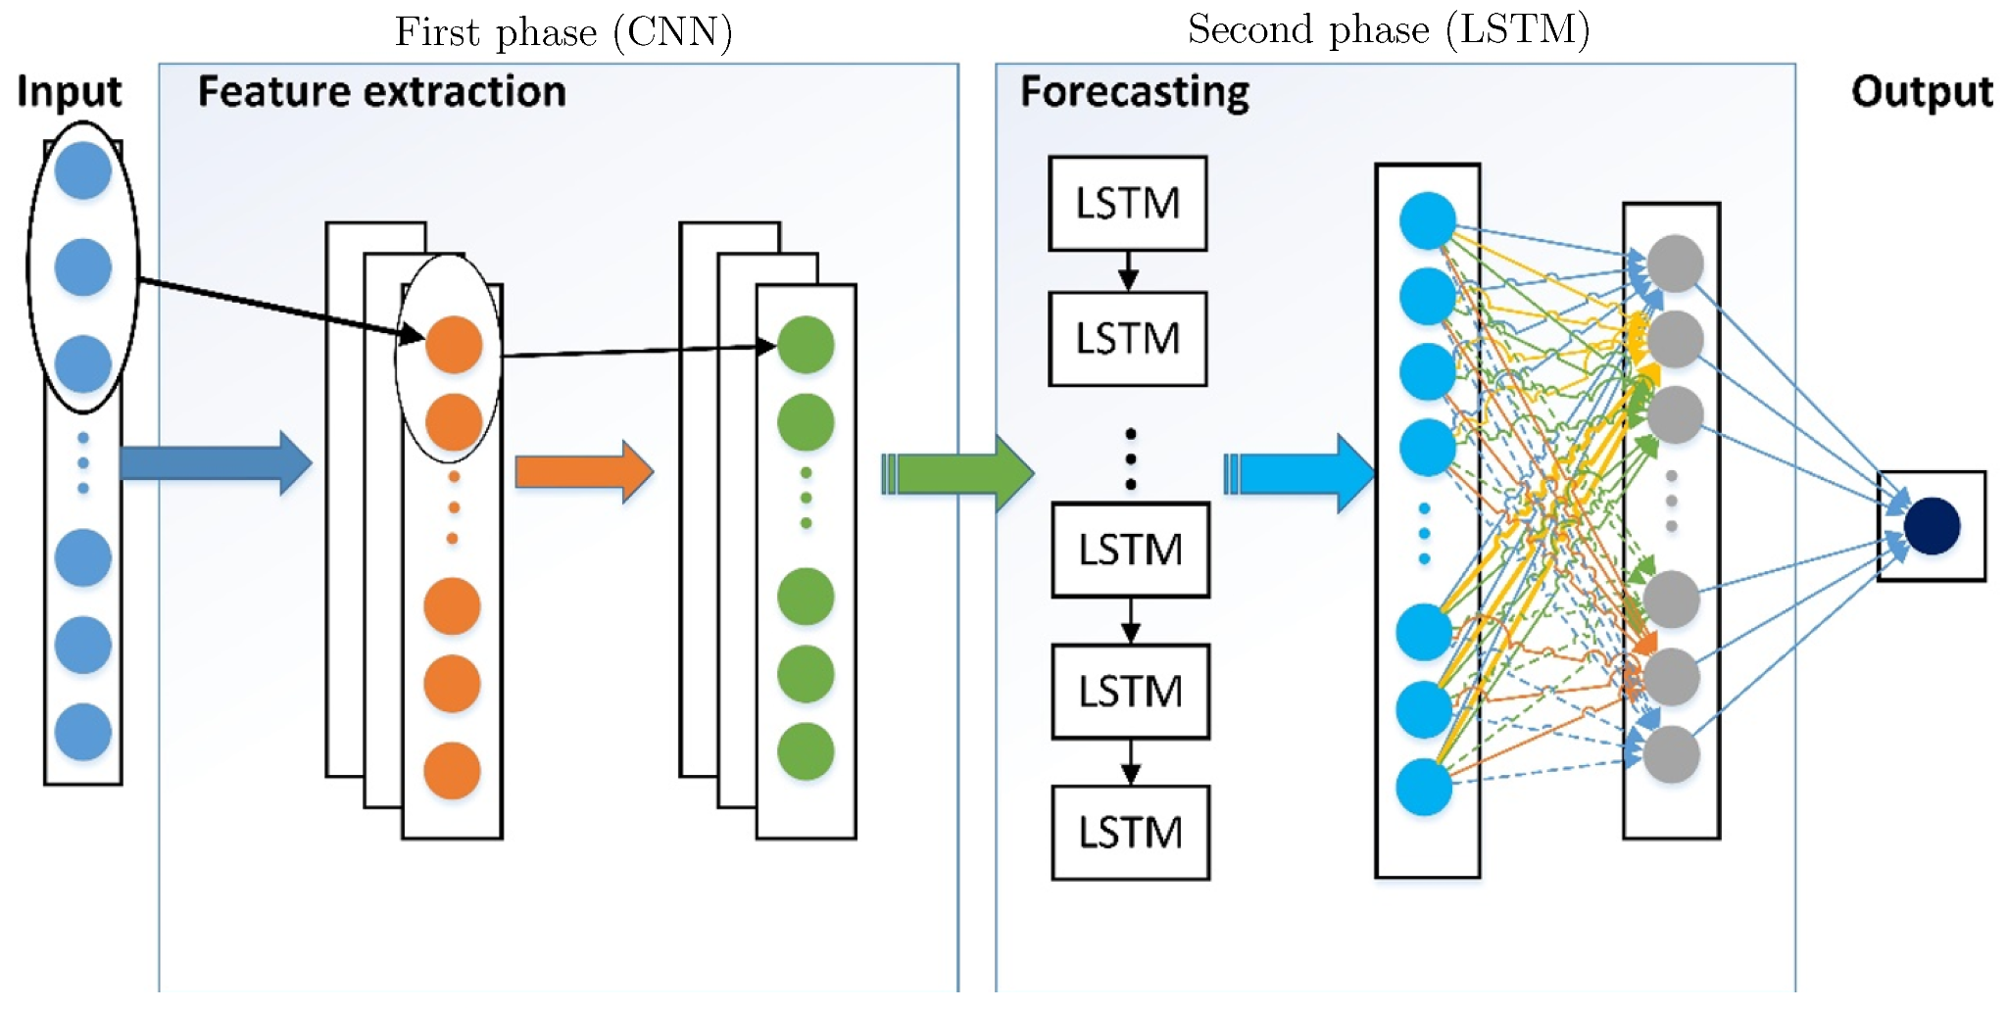

##### Figure 2: The proposed Hybrid DNN power forecasting framework

(Source: https://www.mdpi.com/1996-1073/11/11/3089)

Here the generation of electricity consumption from the various energy power plant has been predicted accurately with the advancement of the stable power supplier. By implementing the CNN and the LSTM model, it helps to extract and to analyse the temporal features with the housing energy consumption prediction. By combining the layers of the convolutional neural networking here the CNN and LSTM method has been applied for the extraction of energy consumption that is proposed to measure the performance of the electric energy consumption for the conventional energy forecasting process, for individual household power consumptions.

According to Ahmad *et al.2020,* In this essay, the authors has clearly focused on discussing the Critical overview of the energy assumptions and also has analysed the future demands of the energy assumptions from the comparative global historical data analysis process in the time series analysis process.

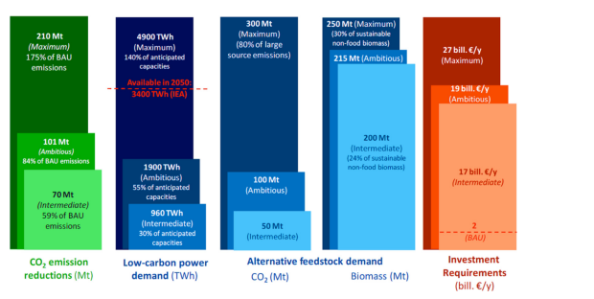

##### Figure 3: The Challenges and opportunities of non-fuel applications

**(**Source:https://www.researchgate.net/figure/Challenges-and-opportunities-for-a-number-of-non-fuel-application-scenarios-by-2050_fig1_343380608**)**

Actually presents the critical description of the energy analysis demands developed by the various business sectors and also analyses the energy supply, the overall trading of the gasses, the time series, and also the adaptation of the renewable energy in contrast to the fuel energy assumptions. Thus it is very helpful to track the demand forecasting processes between 1990 to 2040. It has covered the geographic coverage of the global energy demands in various developed countries, like Brazil, India, China, Russia, South Africa etc.

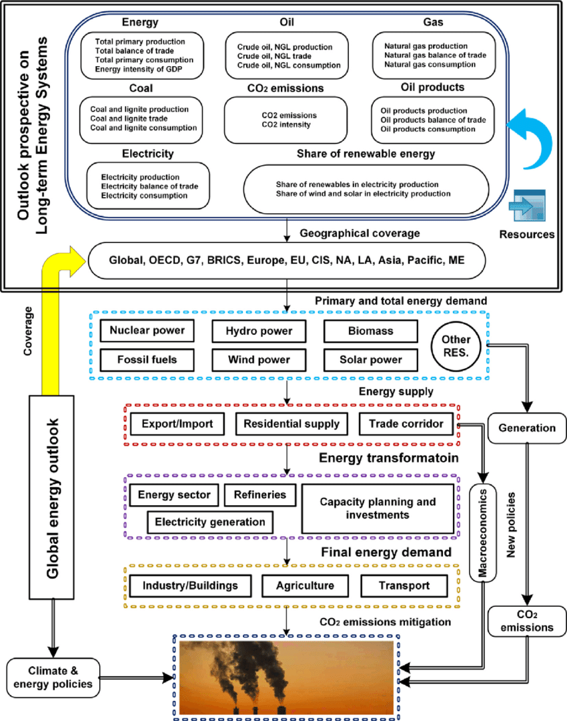

##### Figure 4: Methods of over-global energy reviewing

(Source: https://www.researchgate.net/figure/Methods-of-review-for-the-global-energy-outlook_fig3_343380608)

Analysing the various market strategies with the cooperative policymakers helps by creating an impact on the economic and climatic changes, and also reviews the economic and social development based on the energy trading process.

According to Le *et al*.2019, Here In this essay, the authors has discussed the various concepts regarding the electric energy consumption for the power management system. That would control the development policies for the implementation of the convolutional neural network model and the Bi-directional long-term and short-term memory-biased method for the EECP-CBL model.

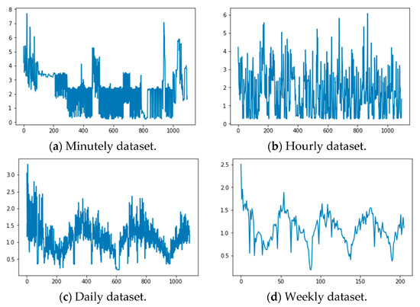

##### Figure 5: The electric energy consumption dataset

(Source:https://www.mdpi.com/2076-3417/9/20/4237 )

That will be helpful for the prediction of the electrical energy consumption that extracts the various electric power consumptions dataset. Thus it also helps to evaluate the trends of the different time series and also evaluate the several layers of the information by predicting the electric energy consumption.

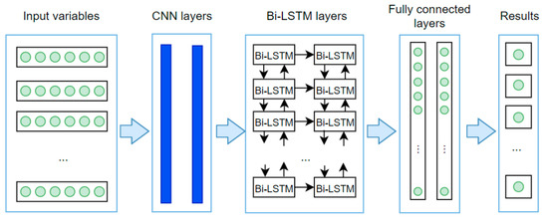

##### Figure 6: The EECP-CBL model architecture

(Source: https://www.mdpi.com/2076-3417/9/20/4237)

From this EECP-CBL model framework, the various performance analysis for the metric solutions can be analysed through real-time, long-term, short-term and also medium-term timespans.

According to Cai *et al*.2019, Here In this essay the Building level load forecasting method by applying deep learning technology in the traditional time series analysis process has been analysed. To meet the objective of the authors the traditional load forecasting method has been applied by utilizing the various statistical approaches in terms of autoregressive analysis. For the integration of the moving averages from the exogenous imputed data that is ARIMAX, that gained the attraction for the classical method time-series analysis process.

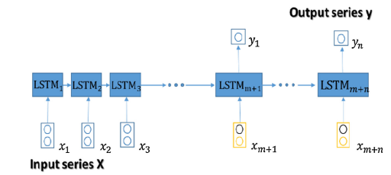

##### Figure 7: The Gated RNN model for building-level load forecasting

(Source:https://ari.vt.edu/content/ari_vt_edu/en/publications_archive/day-ahead-building-level-load-forecasts-using-deep-learning-vs--/jcr%3Acontent/content/download/file.res/128.pdf )

So here by the application of the exceptional capabilities over the development of the deep learning processes, the conventional data-driven networks have been analysed for the time series framework with the load-driven single-step building forecasting process evaluation technique. [***Refer to Appendix 1***]

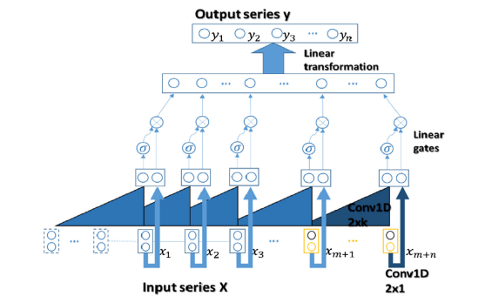

##### Figure 8: Gated CNN model for building-level load forecasting

(Source: https://ari.vt.edu/content/ari_vt_edu/en/publications_archive/day-ahead-building-level-load-forecasts-using-deep-learning-vs--/jcr%3Acontent/content/download/file.res/128.pdf)

Thus it emphasizes the relationship and the commercial environmental process upon which the recurrent neural networking processes have been accumulated for the accuracy, generalizability, robustness and computational efficiency analysis. The ARIMAX seasonal model helps to analyse the performance with the multi-step manners. Having the best performance forecasting accuracy assumption compared with the ARIMAX model it make the process easier. [***Refer to Appendix 2***]

## **2.3 Theories and Models**

Here the application of the time forecasting model over the various energy demand processes has been analysed. ARIMA model: The Autoregressive moving average integration process is the method applying which the time forecasting is generally done (Cai *et al.2019*). Here by combining auto regression, differentiation, and taking the average of the moving the trends and the patterns are analysed. Thus it involves the ARIMA model for the energy demand forecasting for the different time intervals and differs in yearly to hourly methods.

SARIMA model: It is the modified version of the ARIMA model. Thus in this method, the seasonal autoregressive integrated average movement can be measured (Bourdeau *et al.2019*). Thus it helps in the capturing process of the RNN in energy trend data analysis, for the seasonal and non-seasonal component forecasting accuracy process.

Exponential smoothing technique: Here in this process it implies the exponential smoothing process on Holt’s linear model and the triplet model on Holt-Winter’s exponential model. This process helps to observe the historical data by decreasing the weightage of the data and also provides importance to the current data points (Büyükşahin *et al.2019*). It is also known for the simplified and capturing adaptability of the short-term trends for seasonal patterns.

STL: In the seasonal decomposition process, the time series have been analysed for the evaluation of the residual components, the trends of the applied data and the seasonal modelling of the applied data for fulfilling the energy demand exhibitions. Thus here it is also helpful for pattern recognition by measuring the irregularities with the time series decomposition process (Wu *et al.2021*). Thus the STL technique is also helpful for time series energy demand forecasting and modelling process for each of the analysis of the components.

Neural Network: The Artificial neural network is one of the trending processes for gaining popularity in the energy demand forecasting process evaluation (Alhussein *et al.2020*). With the completion of this process, it helps to get the proper capture of complexity accuracy variations with the application of the non-linearity relational data variations and their ability and accuracy assumption. Here these models are also helpful in the long-term memorised data evaluation process and help in the multilayer perceptron model evaluation process that is based on the temporal model and helps to get the energy demand dependability measurement from that time series.

SVR: Another important process of time series analysis is the support vector m, machine analysis technique. Here in this process, the best-fitted data is assumed by the regression analysis process. Thus in this method by minimizing the data variants or by reducing the errors of the applied data the hyper plane is applied to the specific data model (Hewage *et al.2020*). Thus in this process, the energy demand is generated through a time series model by the seasonal factors, the other relevant data predictive components and the lagging of the variables are assumed.

Gaussian Process: The predictive model analysis for the long-term and short-term trend analysis; GP is also a very important method (Li *et al.2019*). Thus in this method, the variations are assumed by incorporating the different components in the time series analysis process. Thus here the flexibility of the frameworks helps to analyse the seasonality, trends and noise involved in the forecasting process. Thus this process is beneficial in the non-linear uncertain data analysis method.

Thus here are various types of methods are available for the evaluation of the time series analysis over the assumptions of the pattern recognition technique in the time series model. The models by selecting, which the dependent factors are analysed are also helpful for the data characteristics evaluation, the specific requirement basis process that is dependent on the availability of the resource assumptions (Alsharif *et al.2019*). Also, it is beneficial for the flexibility assumptions beyond the frameworks that help to calculate the performance accuracy measurement with the identification of the easiest and most suitable process for the specific application.

## **2.4 Literature Gap**

Here from the above descriptions though it is very helpful for accommodating the Time series forecasting model over the Energy demand distribution over various countries. It follows some problems regarding the implementation of those techniques in a real time research process. Thus here problems arose in the implementation of the expected observations for the time series data analysis process (Zhong *te al.2019*). It does not accommodate the same observatory series further away, moreover, it does not analyse the accountability over the assumptions of the seasonality for the non-stationary means. Also, the measurement of several statistical approaches has been applied here for the evaluation of the performance accuracy. Sometimes for the extraction of the characteristics some issues can be faced due to the changes in the time sequencing and also the some challenges can be faced in the establishment of the forecasting methods. Thus as that is totally dependable on the stationary data points it suffers due to the limited historical data evaluation process that lacks the new data production and creates so much human error in data accuracy measurement and seasonality measurement process.

## **2.5 Conceptual Framework**

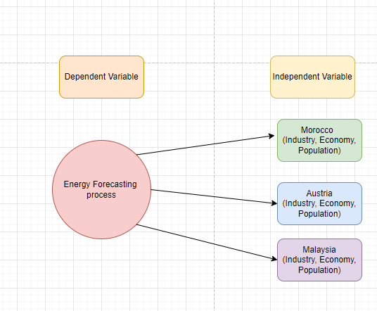

##### Figure 9: The Conceptual Framework

(Source: Self-created in Draw.io)

## **2.6 Conclusion**

Here from taking the idea about various perceptions over the implementation process of the time series evaluation for the measurement of the predictive analysis over the historical data-based inputs. It helps to amplify the knowledge over the assumptions for the accumulation of the time-stamped data that involves the various building models. It also helps by making the observations by the data-driven methods for the decision-making strategy. Thus by applying convolutional data modelling for the application of several machine learning techniques in the time series analysis over the applied historical data can be evaluated. That helps to meet the objectives of the proposed model and also helps to get the proper knowledge about the time series model.

# **Methodology**

## 

## **3.1 Introduction**

Time series analysis is the specified method of analysis by which the data points sequencing is analysed from the collected dataset. Thus it can be said by the help of the time series analysis the data points can be implemented through the collection over real-time intervals. Thus here the time series analysis has been done through Python in the Google Colab platform using exploratory data analysis over the historical data. Thus with the help of the proper time series analysis h, ere the energy demand forecasting has been done for the understanding of the patterns through the selection of the appropriate forecasting model. Before doing the time series analysis here the data required the training and testing for the performance evaluation. That process has been done on the basis of the three locations for the accurate predictive model for the future energy demand based on the historical data.

## **3.2 Method Outline**

For doing the proper time series analysis it follows some of the process; like the scatter plot, box plot, histograms, pie charts etc. Thus before applying the time series analysis, the data has to be collected. This data again comprised of the various ordered sequencing of the historical data, which are equally specified for equal intervals. Rather than understanding the time series analysis here, it helps into the randomly specified data for the different trends that best-fit for the different applied filter values and do the analytical process to emphasize the data into a new time series predictive model with the evaluation of the data points indeed in the order of time (Lara-Benítez *et al.2020*). Again these time series data is divided into two parts one is for the frequency domain analysis and the other is measured for the time domain methods. After doing the training process the data is sent for the classification process, after which the curve has been fitted for making the relationship with that data. Then this process is further followed by the descriptive and explorative analysis of the applied dataset.

## **3.3 Research Philosophy**

Here in this perception, the time series analysis has been applied for the evaluation of the fundamental features of the energy demand distribution that creates the correlation with the various observatory data (Le *et al.2019*). Thus with the application of the stained statistical methods, the time series is analysed that contains a large amount of data, for the insurance of the consistency and the reality of the applied data with the measurement of various attributes for a certain period and the information generated about those applied attributes (Ahmad *et al.2020*). In this process based on the temporal data, this method has been analysed on a specific parametric that extracts the statistical information and also analyses the time domain and the frequency applied to that data.

## **3.4 Research Approach**

For doing the time series analysis here the quantitative methods have followed. Thus by the primary data analysis of the applied dataset here the forecasting of the energy demands with the implementation of the historical data has been evaluated. Thus by the identification of the various patterns in the applied data, here the future demand prediction has been done with the pattern recognition process and it is also analysed by the exploratory data analysis process (Moon *et al.2019*). There are several types of methods are present like the ARIMA, MA and the ARIMAX method for the autoregressive analysis process distribution with the integration of the moving average for the statistical evaluation of the proposed model data.

## **3.5 Research Design**

The time series analysis is done by the visualization of the applied data. It is very essential to emphasize and recognize the trends of the time grids that priority to the modulation process or the building method time series from applied historical data (Runge *et al.2019*). After that, the visualized data is sent for the evaluation process where the time series data is observed or rationalized for the applied dataset. In the next step, the data optimization has been done on the basis of the various parametric approaches for the application of the ARIMA model in the following process of evaluation. Thus it finally helps to get the proper predictive model of the applied dataset (Kim *et al.2019*). Here in this context though the descriptive or the exploratory data analysis has been done for the distribution of the energy demands in the various areas. It also follows the correlational analysis that demonstrates the diagnostic evaluation from the experimental dataset.

## **3.6 Research Strategy**

For the specialized way of data sequencing and to do the proper time series analysis of the applied dataset at first the data is collected and after that, the data points are analysed through intervals of time. Also, the time series analysis is recorded through the various data points for the consistency of the intervals of the time analysis (Tan *et al.2019*). Also here this method follows the random method of data other optimization process.

## **3.7 Data Collection Method**

For doing the proper analysis of the time series data here the various historical data are collected from the industrial dataset in this proposed model. Thus here based on the industries like retailing, finance and other economical states, the data is evaluated for the energy assumptions in three different countries (Zhou *et al.2021*). Also al this statistical modelling approach is applied for the decision-making and predictive analysis of the applied time series data model. Thus on the basis of this series of data, the meaningful characteristics and the data extraction is done for the future value predictions, which is observed by loading the data models for their forecasting the energy demands for their pricing and also involved the renewable energy sources for the expected pricing values and adaptive probability assumptions.

## **3.8 Data Analysis**

Here the data analysis is done by taking the classification, of the applied data and after identification of those data it is assigned for categorization (Wan *et al.2019*). Here the curve is fitted for the representation of the relational plots along with the applied deliberate variables within the data model. Thus by the evaluation of the exploratory data analysis process, the patterns are recognized and it is also implemented in the time series data for the proper seasonal variations.

## **3.9 Research Limitations**

In the building process of the time series analysis model, where the data points suffer from weaknesses and also suffer from the generalization of the single-step duty analysis, where the difficulties are obtained for the measurement of the appropriate performance analysis measurement (Wang *et al.2019*). Also, it lags in the identification process of the accurate model evaluation by which the model data can be represented.

## **3.10 Time Horizon**

##### Figure 10: The Gant Chart

(Source: Self-created in Project Libra)

## **3.11 Conclusion**

The energy demand forecasting process by the implementation of the time series method is helpful for the analysis of the statistical and economic data evaluation. Thus on the basis of the predictive model, the future assumption has been observed by analysing these data points. Here by analysing the seasonality, randomness and various attributes, the sales have been analysed for the three different countries.

# **Implementation**

## 

## **4.1 Introduction**

The project is about time series analysis for energy demand using Python. The main aim of the project is to find the comparison of the demand for energy in various countries such as Austria, Malaysia, and Morocco and also predict the future trend for the energy demand. By using the data analysis field, useful insights and patterns can find out from the dataset. From this data analysis, it would be understood the demand for the energy year-wise, month-wise, week-wise, quarter-wise, hourly-wise, day-wise. By understanding this, the energy-producing organization can strategies their plan for producing the energy in a sufficient amount and supplying energy in those countries. The whole project has been done with the help of the Python programming language and the Jupyter Notebook software is used to implement this.

## **4.2 Analysis**

**Data Pre-processing**

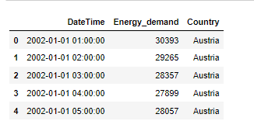

##### Figure 11: Loading of the dataset

(Source: Self-created using Jupyter Notebook)

The dataset has been collected in a CSV file. The CSV file has been loaded into the Jupyter Notebook. The dataset is loaded in tabular form (Hu and Chen. 2022). The dataset has only 3 columns such as Date Time, Energy demand, and the country. The country has the 3 levels such as Austria, Malaysia, and Morocco.

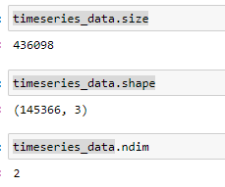

##### Figure 12: Structure of the dataset

(Source: Self-created using Jupyter Notebook)

Now, the structure of the dataset has been evaluated. The data frame consists of the 3 columns and 145366 records (Kim *et al.* 2022). The energy demand dataset’s size is 436098. The dataset is 2 dimensional.

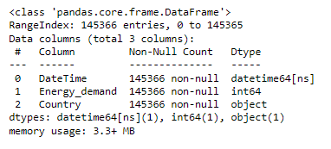

##### Figure 13: Information of the dataset

(Source: Self-created using Jupyter Notebook)

Here the step is to analyse information from the energy demand dataset. In this dataset, the Date Time column is date time type, energy demand is the numeric type and the country column is the object type. The storage of the dataset is 3.3+ MB.

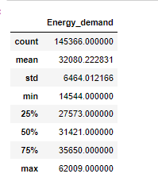

##### Figure 14: Summarization of the dataset

(Source: Self-created using Jupyter Notebook)

Now, the task has been to implement the summarization of the data with the help of the describe method (Li and Wang. 2022). The summarization of the numeric column such as energy demand is evaluated by the mean, standard deviation, maximum value, min value, 75% quartile, 25% quartile, and first quartile.

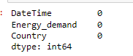

##### Figure 15: Checking the missing values

(Source: Self-created using Jupyter Notebook)

Now the task is to check the missing value in the columns of the dataset. Missing value lead to biases during the data analysis(Xing *et al.* 2019). After checking the missing value, it has been understood that there is no missing value.

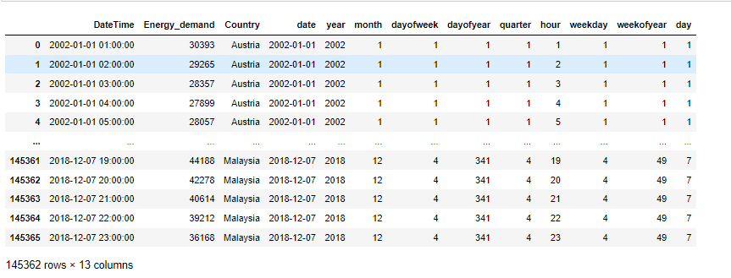

##### Figure 16: Create required columns

(Source: Self-created using Jupyter Notebook)

Some new columns have been created for analysing the trend. A few additional columns such as date, month, year, day of the week, day of year, quarter, hour, weekday, week of the year, and day columns are created in this data frame.

**Data visualization**

Data visualization is done using the line chart to understand the trend of the demand for energy. The matplotlib library is used for plotting the line chart.

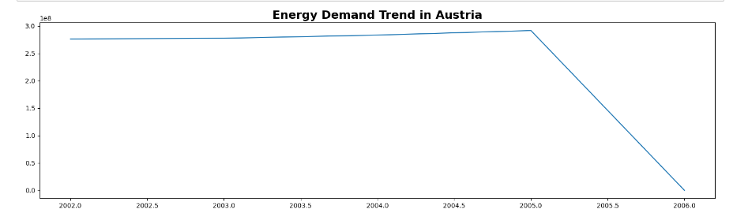

##### Figure 17: Yearly Energy demand Trend in Austria

(Source: Self-created using Jupyter Notebook)

This line chart is plotted for visualizing the trend line to understand the energy demand yearly in Austria. From the visualization, it has been analysed that, from 2002 to 2006, the deemed for energy is slightly increase yearly in Austria.

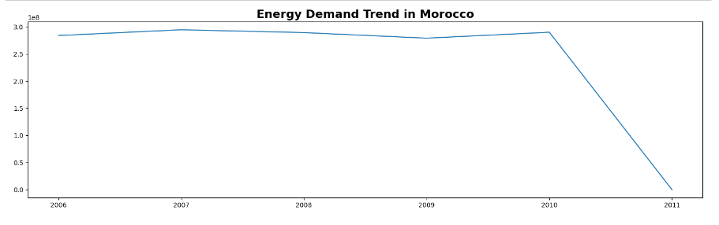

##### Figure 18: Yearly Energy demand Trend in Morocco

(Source: Self-created using Jupyter Notebook)

This line chart is plotted for visualizing the trend line to understand the energy demand yearly in Morocco. From the visualization, it has been analysed that, from 2006 to 2007, the deemed for energy slightly increased, and after that, till 2009, demand is slightly decreasing.

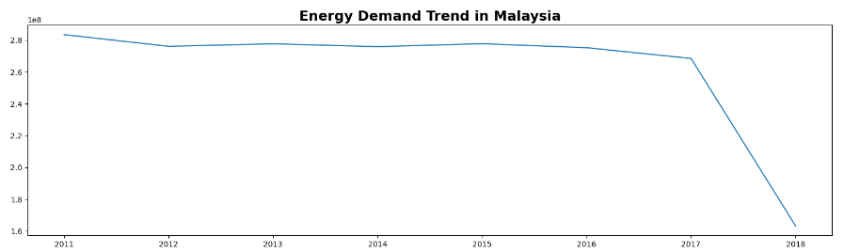

##### Figure 19: Yearly Energy demand Trend in Malaysia

(Source: Self-created using Jupyter Notebook)

This line chart is plotted for visualizing the trend line to understand the energy demand yearly in Malaysia. From the visualization, it has been analysed that, from 2011 to 2017, the demand for energy slightly decreased.

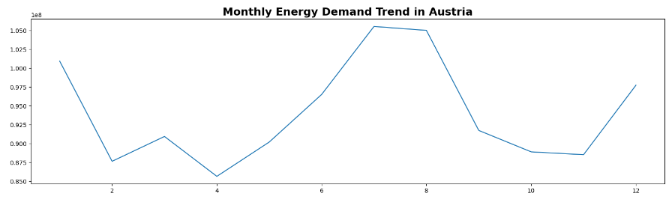

##### Figure 20: Monthly Energy demand Trend in Austria

(Source: Self-created using Jupyter Notebook)

In July month, the monthly energy demand is more in Austria.

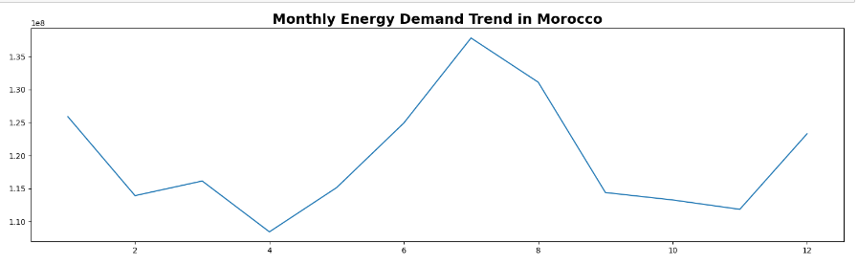

##### Figure 21: Monthly Energy demand Trend in Morocco

(Source: Self-created using Jupyter Notebook)

In July month, the monthly energy demand is more in Morocco.

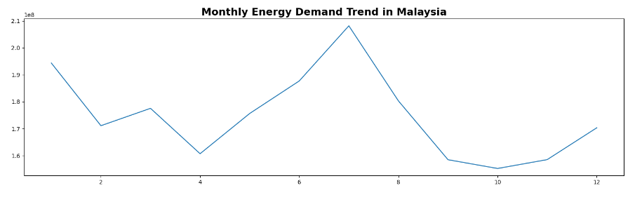

##### Figure 22: Monthly Energy demand Trend in Malaysia

(Source: Self-created using Jupyter Notebook)

In July month, the monthly energy demand is more in Malaysia.

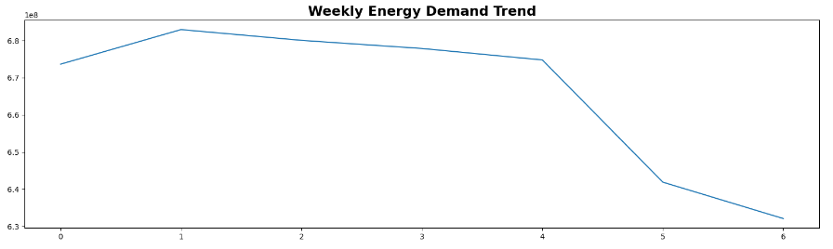

##### Figure 23: Weekly Energy demand trend

(Source: Self-created using Jupyter Notebook)

The line chart is plotted to visualize the trend of the energy demand weekly. From the visualization, it has understood that on the 2nd day of the week, the energy demand is more.

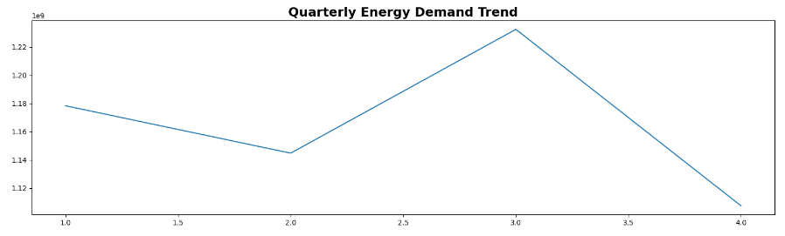

##### Figure 24: Quarterly energy demand trend

(Source: Self-created using Jupyter Notebook)

In the 3rd quarter, the energy demand is more than the other quarter. The quarterly energy demand trend is visualized using the line chart. The demand for energy is less in the second quarter.

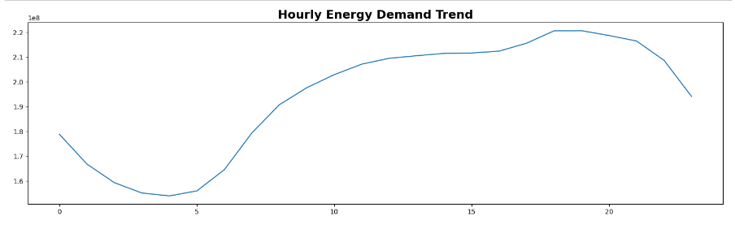

##### Figure 25: Hourly Energy demand trend

(Source: Self-created using Jupyter Notebook)

In between 5 to 18 hours, the energy demand is more. The hourly energy demand is increasing from the 5th hour to the 18th hour. The hourly demand is less in the 4th hour. ***[Refer to Appendix 3]***

## **4.3 Conclusion**

From above study I can conclude, that the proper data analysis is done on the demand for energy to understand the trend in Austria, Malaysia, and Morocco. The data analysis floors some steps in this project. First, the dataset is collected from the Kaggle dataset. They can likewise show in general patterns by plotting long time periods. Visual components like variety coding bars, adding mistake bars, and including marks/legends give further setting. This makes them ideal for imagining routinely divided time series information like month-to-month measurements, model expectations at set spans, or total outcomes like aggregates or midpoints throughout uniform time cans. After that quality of the dataset has been accessed. The Line chart has been visualized to visualize the trend. From the visualization, some facts have been found such as the hourly energy demand increasing from the 5th hour to the 18th hour. In the 3rd quarter, the energy demand is more than the other quarter. The whole project is implemented using the Python programming language and the Jupyter Notebook software.

# **Results**

**5.1 Evaluation**

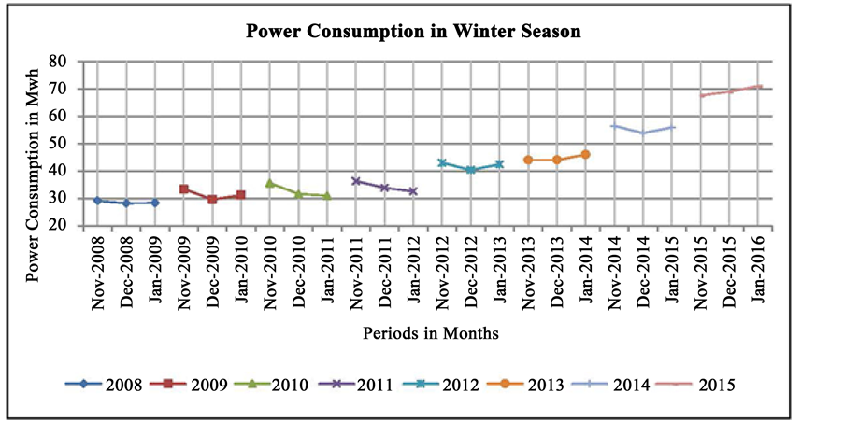

**Figure 2: Consumption of energy in winter**

(Source: https://th.bing.com)

The above figure is the chart of energy consumption in the season of winter. The chart is a total time series analysis of energy consumption. The chart shows the graph of power (energy) consumption versus periods in a month. The data shows starting from the year 2008 to 2015. On November 2008 it has been observed that the energy consumption is 30 Mwh. In the month of January 2011, there is observed an increase in energy consumption that is 35 Mwh. In December 2012 energy consumption is 40 Mwh. In December 2014 energy consumption is 55Mwh. In 2016 there is observed a massive energy increase (Ahn *et al.*2022). The energy is 70 Mwh.From November 2008 to January 2016 analysis it is observed that it is a slow and continuous increase of the rate of energy consumption. In January 2016 there is a massive increase in the rate of energy consumption.

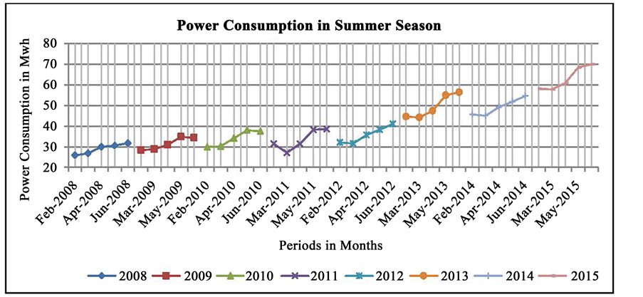

**Figure 3: Consumption of energy in summer**

(Source: https://th.bing.com)

The above figure is the chart of energy consumption in the season of summer. The chart is a total time series analysis of energy consumption. The chart shows the graph of power (energy) consumption versus periods in a month. The data shows starting from the year 2008 to 2015. On February 2008 it has been observed that the energy consumption is 25 Mwh. In the month of March 2011, there is observed an increase in energy consumption that is 40 Mwh. In March 2013 energy consumption is 59 Mwh. In March 2015 energy consumption is 55Mwh. In May 2015 there is an observed massive energy increase (Wu *et al.*2020). The energy is 70 Mwh.From February 2008 to May 2015 analysis it is observed that it is a slow and continuous increase of the rate of energy consumption.

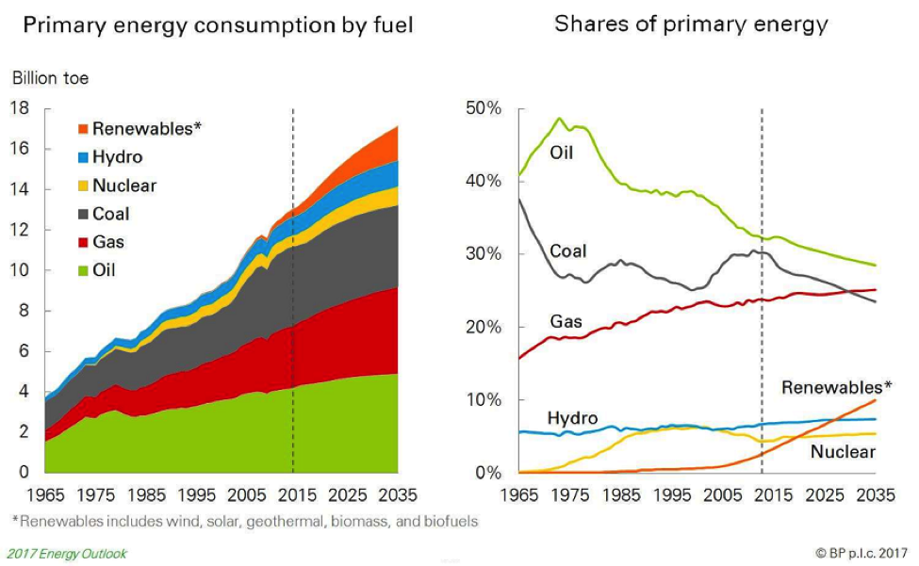

**Figure 4: Energy consumption and its share**

(Source: https://th.bing.com)

According to the above figure, there is the amount of the primary energy consumption by the fuel throughout the past years and the upcoming year also. It has been observed that the energy consumption rate is calculated for renewables, hydro energy, nuclear energy, coal consumption, gas energy, and for oil consumption. There is also a given share of primary energy. The share of nuclear energy in the year 1965 is 0% and in 2035 it would be 10%. The hydro energy consumption in the year 1965 was 5% and in 2035 would be 11%. The gas consumption in the year 1965 was 17% and in 2035 would be 22%. Coal energy consumption in the year 1965 was 39% and in 2035 would be 21% (Challu *et al.*2023). Oil energy consumption in 1965 was 40% and in 2035 it would be 31%. So, after the analysis, it has been observed that the coal energy consumption and the oil energy consumption would decrease. But there would be an increment in gas and renewable energy consumption. As the amount of non-renewable energy resources decreases day by day.

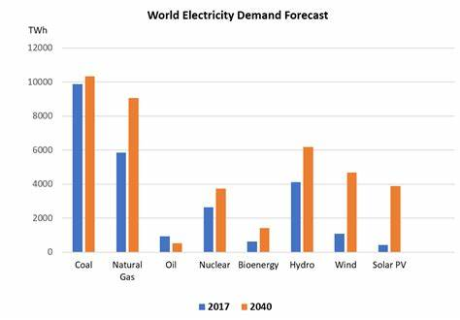

**Figure 5: World Electricity Demand Forecast**

(Source: https://th.bing.com)

The above figure is the description of the world electricity demand forecast. It is also energy demand forecasting. From the above figure, it is observed that in the year 2017, the energy consumption rate by coal is 10000 Twh, by natural gas is 6000 Twh, by oil is 1000 Twh, by nuclear energy is 2100 Twh, by bioenergy is 500 Twh, by hydro energy is 400 Twh, by wind energy is 500 Twh, by Solar PV is 10 Twh. It is observed that the energy consumption rate by coal is highest than the other. The smallest energy consumption rate is for solar PV. Because it is renewable energy resources. Also, the energy consumption rate for then wind energy is less. The researcher has predicted a forecast that the energy consumption rate in the year 2040 may be of the following (Zeng *et al.*2023). In the year 2040, the energy consumption rate for coal would be 11000 Twh, for natural gas would be 6000 Twh, for oil it would be 5 Twh, for nuclear energy it would be 4000 Twh, for bioenergy it would be 1500 Twh, for Hydro energy it would be 600 Twh, for wind energy it would be 4500 Twh, solar PV it would be 4000 Twh. The energy consumption rate from solar PV would also increase in the year 2040.

**5.2 Data analysis**

In the data analysis section, the data set is loaded first and the structure of the data is evaluated after loading the data (Chou *et al.* 2019). Also lastly by the visualization techniques, various charts have been plotted for finding the pattern of the demand for energy.

# 

##### Figure 26: Variance Calculation

(Source: Self-created using Jupyter Notebook)

Variance calculations how far every information point spreads from the mean worth in a period series dataset. It evaluates the changeability in the information. To work out fluctuation, first, register the mean of the time series by adding every one of the perceptions and partitioning by the all-out number of data of interest. Then, at that point, for every data of interest, work out the squared contrast between its worth and the mean. Total this multitude of squared contrasts and separation by the quantity of information focuses less one. This gives the fluctuation - a bigger difference esteem demonstrates the information is more fanned out from the mean, while a little change shows it groups intently around the mean. Variance is valuable for contrasting the instability of various time series. It additionally includes in further developed time series ideas like autoregressive models. High unpredictability makes time series more challenging to foresee, so evaluating difference helps measure the intricacy of demonstrating a specific dataset after some time.

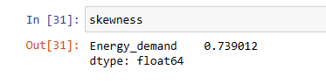

##### Figure 27: Skewness of moments Calculation

(Source: Self-created using Jupyter Notebook)

Skewness measures the imbalance of the likelihood dispersion of a period series around its mean. A decidedly slanted dispersion has a long right tail, while an adversely slanted circulation has a long left tail. To ascertain skewness, first track down the mean and standard deviation of the time series. Deduct the mean from every data of interest and separate by the standard deviation, giving the normalized values. Block these normalized values and view as normal - this is the third second about the mean. At long last, partition the third second by the standard deviation raised to the third power. The subsequent worth is the skewness. A skewness of 0 demonstrates a symmetric conveyance. Positive skewness implies more outrageous positive qualities, while negative skewness demonstrates more outrageous negatives. Evaluating skewness decides the state of information conveyance and reasonable anticipating models. Exceptionally slanted time series might require change before the examination. Understanding skewness additionally helps the translation of expectations from time series models.

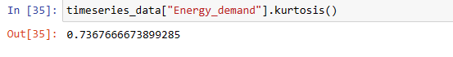

##### Figure 28: Kurtosis Calculation

(Source: Self-created using Jupyter Notebook)

Kurtosis calculates the greatness of the tails of a period series dissemination contrasted with a typical circulation. It shows how likely outrageous qualities are to happen. To ascertain kurtosis, first track down the mean and standard deviation of the time series. Deduct the mean from every data of interest and gap by the standard deviation to get normalized values. Take the fourth force of each normalized worth and view it as the normal - this gives the fourth second about the mean. Partition the fourth second by the standard deviation to the fourth power. Take away 3 from this outcome to work out overabundance kurtosis. A positive overabundance of kurtosis shows weighty tails and more outrageous qualities contrasted with typical dissemination. A negative overabundance kurtosis demonstrates lighter tails. Kurtosis decides exceptions, the need for information changes, and the reasonableness of estimating models that expect ordinariness. Higher kurtosis suggests more fluctuation in projections. Evaluating kurtosis gives data on the state of the information dispersion basic for deciphering and precisely demonstrating time series information.

## 

##### Figure 29: Bar Graph using data frame visualization

(Source: Self-created using Jupyter Notebook)

Bar graph using data frame visualization are a typical method for predicting time series information put away in an information outline. With the time variable on the x-pivot and the worth variable on the y-hub, each time span can be addressed by a rectangular bar with level corresponding to the information esteem. Reference charts permit simple correlation of values across various time spans. Variety coding bars by classifications or utilizing assembled bars to address numerous factors gives further bits of knowledge. Choices like mistake bars demonstrate changeability in point gauges. Bar graphs can likewise sum up time series qualities like occasional changes and patterns when plotted for longer time periods. They assist with recognizing designs over the long haul. Customizations like marks and legends explain the full setting. Visual diagrams are restricted by not associating individual data of interest, so need smooth patterns of line plots. Be that as it may, their effortlessness, instinct, and capacity to feature correlations make structured presentations an essential time series representation procedure, particularly for discrete information like month-to-month or week-by-week measurements or model outcomes summed up at set expectation stretches.

## 

##### Figure 30: Bar Graph visualization

(Source: Self-created using Jupyter Notebook)

A bar graph is a basic yet powerful method for imagining time series information. It plots rectangular bars with levels relative to the information values for each time span. The bars are separated at equivalent spans on the flat pivot addressing the time aspect, while the upward hub catches the extent of the information. Bar diagrams can feature designs like occasional vacillations at customary intermittent stretches. Their effortlessness and instinct makes reference diagrams a central instrument for time series information representation and investigation.

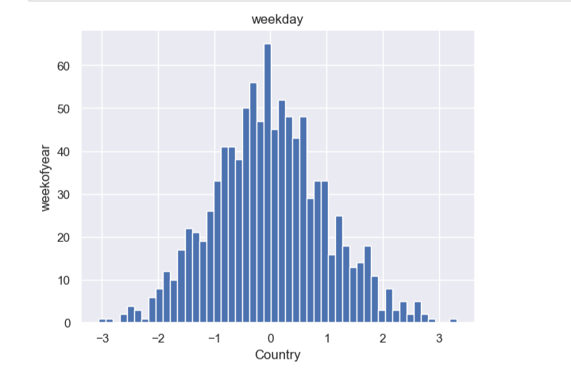

##### Figure 31: Histogram Graph visualization

(Source: Self-created using Jupyter Notebook)

Time series histograms can uncover examples and patterns in information over the long run. Dissimilar to standard histograms which show the dispersion of a solitary dataset, time series histograms imagine the progressions in conveyance of a measurement throughout different time spans. For instance, a histogram for site traffic could show day to day guests for every month more than a year. This permits you to see increments or diminishes in rush hour gridlock over the long haul. Time series histograms make it simple to detect occasional cycles and exceptions initially. The state of the circulation might move from one month to another, demonstrating evolving patterns. Spikes or dunks in specific time spans are apparent as bars that stand apart from the general example. Looking at histograms next to each other makes patterns and oddities more obvious. Changing the receptacle size can feature various parts of the information. Time series histograms give a conservative representation to figuring out circulations, varieties, and examples across fleeting information. They consolidate complex time series data into a straightforward visual organization for fast investigation and examination.

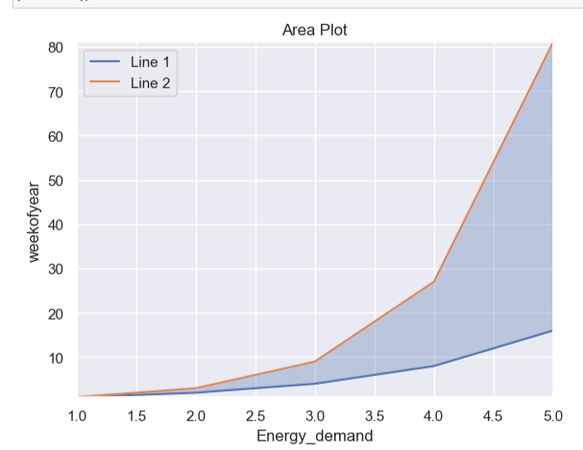

##### Figure 32: Area graph plot visualization

(Source: Self-created using Jupyter Notebook)

Area diagrams are powerful for envisioning time series information. Dissimilar to line diagrams which just associate pieces of information, Area charts occupy the space under the line to accentuate the extent of progress. The filled Area addresses the aggregate all out of the measurement over the long run. This makes it simple to analyse sums across various time spans. For instance, an Area diagram of site traffic would show a filled locale addressing all out guests each month. Higher Areas show more traffic. Plunges or valleys uncover times of low traffic. The incline of the line shows whether the information is expanding or diminishing. More extreme slants address quicker paces of progress. Area diagrams make it simple to distinguish designs like occasional changes and generally drifts. Contrasting numerous Area diagrams permits you with contrast different time series. Generally speaking, Area charts feature the combined effect of changes over the long haul. The filled Area centres consideration around the absolute worth and how it advances. For time series information, Area diagrams are more powerful than line graphs at conveying size and patterns.

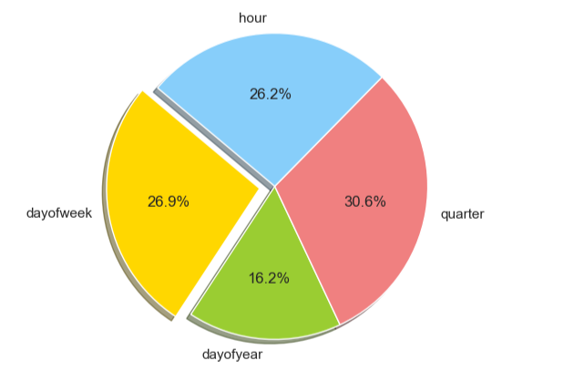

##### Figure 33: Pie chart Graph visualization

(Source: Self-created using Jupyter Notebook)

Pie outlines are not extremely successful for imagining time series information. Not at all like histograms or region diagrams, are pie outlines not intended to show changes after some time. Every pie chart regularly addresses a solitary time span, with cuts of the pie addressing classifications or fragments of information. To imagine patterns after some time, numerous pie diagrams for various time spans should be drawn next to each other. This can consume a great deal of visual space and makes correlations troublesome with continually changing pie sizes and cut points. Thus the pie chart for the given time series analysis dataset is visualized and filtered and also statistically calculated which shows day of year, quarter, day of week and hour to make the comparison more accurate. For time series information, it is smarter to utilize a diagram like a line outline where the patterns and direction of the information are outwardly encoded as slants and bends. Pie diagrams are more helpful for showing corresponding correlations or breakdowns across various classifications in a solitary time span. In any case, for imagining designs over the long haul, histograms, region diagrams, bar outlines, and line charts are by and large preferable decisions over pie charts.

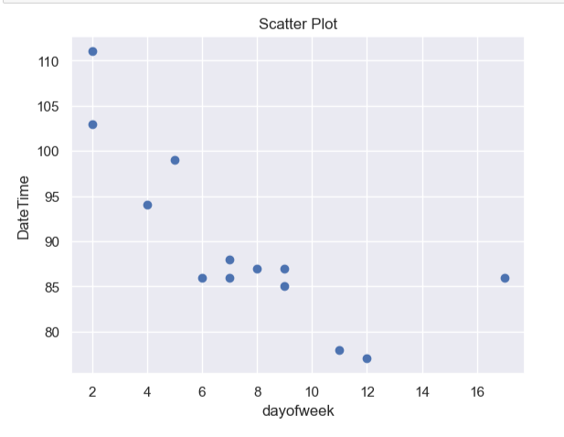

##### Figure 34: Scatter plot visualization

(Source: Self-created using Jupyter Notebook)

Scatter plots can be a successful method for picturing time series information. The x-hub addresses time, while the y-hub plots the upsides of the time series. Every information point is plotted as a point on the chart. The dissipate plot shows the connection among time and the measurement being estimated. Patterns become apparent as the thickness and slant of focuses. Up slants demonstrate expanding values over the long haul. Descending slants show diminishing qualities. The steepness of the slants demonstrates the pace of progress. The main part for the scatter plot is that it quickly visualizes and compares the time series data between the day of week and day of time. Gathering data of interest into ordinary time spans can uncover repetitive examples. Fitting pattern lines to the information focuses helps feature generally speaking increment or abatement. Vivified dissipate plots can show much more obviously how time series information advances. In general, Scatter plots convey a straightforward yet adaptable perception for dissecting patterns, cycles, and exceptions over the long haul. Line plots make it simple to distinguish repetitive examples that are recurrent over the long haul. Logical data like objective qualities or verifiable midpoints can be added to help examination. Enlivened line plots can represent how time series develop. Basic yet adaptable, line plots permit instinctive investigation of patterns, paces of progress, anomalies, and occasional examples over the long haul. They change crude information into a quick visual rundown of how measurements differ after some time.

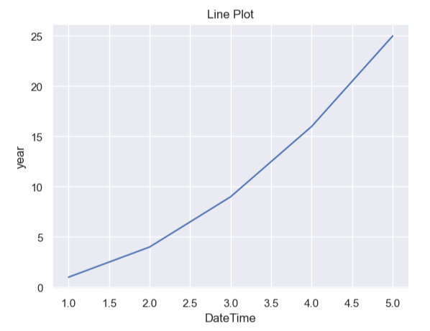

##### Figure 35: Line Plot visualization

(Source: Self-created using Jupyter Notebook)

# **Conclusion**

## **6.1 Introduction**

Time series analysis is a strong factual instrument utilized for estimating energy demand forecast. By inspecting verifiable examples and recognizing patterns, irregularity, and other persuasive elements, it takes into account exact forecasts of future energy prerequisites. This analysis supports navigation, asset portion, and supportability arranging in the energy area.

## **6.2 Linking with Objectives**

**To develop imaginative time series analysis models and methods that can successfully catch and break down complex worldly examples in energy demand forecast.**

The first objective described above plan to accomplish a few vital results in the field of energy demand estimate. By creating innovative time series examination models and techniques, the objective is to successfully catch and break down complex certifiable models in energy demand forecasting.

**To expand the precision and unwavering quality of energy demand forecast by assessing and further developing existing determining techniques.**

The objective is to improve the accuracy and dependability of energy demand estimates by assessing and upgrading existing anticipating strategies. This includes distinguishing the qualities and shortcomings of current strategies and carrying out upgrades to build the exactness of expectations.

**To create models and procedures that can give ongoing energy demand forecasts, empowering better navigation and asset-anticipating energy providers.**

This objective is to foster models and techniques that give ongoing energy demand conjectures. This will empower energy suppliers to pursue more educated choices and designate assets actually. By approaching advanced models, energy suppliers can all the more likely deal with their tasks and satisfy client needs proficiently.

**To assess and evaluate the vulnerability related to energy demand forecast by integrating vulnerability measures.**

This objective is to survey and assess the weakness related to energy demand anticipating by consolidating weakness measures. This incorporates recognizing expected dangers and vulnerabilities that might influence the precision of figures and tracking down ways of relieving them.

## **6.3 Future scope**

Time series analysis has turned into a fundamental apparatus for determining energy interest as of late because of its capacity to dissect verifiable information and recognize examples and patterns that can be utilized to make precise expectations for what's in store. As the energy scene keeps on developing, time series investigation offers a promising future degree for energy demand forecast.

One part of time series analysis that holds incredible potential is the fuse of IoT (Internet of Things) gadgets into the information assortment process. With the rising sending of brilliant meters and sensors in homes and organizations, a tremendous measure of information can be gathered continuously, giving a more exact portrayal of energy utilization designs. This information can be utilized as time series forecast to encourage more exact energy interest figures, assisting energy suppliers with improving the age and conveyance of power.

Development in ML and artificial intelligence are changing time series analysis in energy demand forecasting. By consolidating calculations that can naturally distinguish and adjust to changing examples and irregularities in the information, energy suppliers can improve the exactness and dependability of their figures. These calculations can likewise change the conjectures progressively as new information is gathered, prompting more productive independent direction and framework arranging. One more area of future scope for time series analysis in energy demand forecasting is the thought of outer variables. Atmospheric conditions, financial variables, government strategies, and socio-social changes all effect energy utilization designs. Time series analysis can add to the improvement of interest reaction programs, which mean to change energy utilization in light of supply requirements or cost variances. By dissecting verifiable information on energy use and purchaser ways of behaving, energy suppliers can distinguish potential interest reaction valuable open doors and plan compelling methodologies to oversee top interest periods. This can assist with diminishing burden on the framework and alleviate the requirement for costly foundation updates.

## **6.4 Recommendation**

There are various models that can be recommended for the research on time series analysis for

Energy demand forecasting which are given below.

**Choosing an appropriate model**: Choosing the suitable time series model is vital. Well known procedures like ARIMA (Autoregressive Integrated Moving Average) or SARIMA (Seasonal ARIMA) models are generally utilized for energy request forecasting. Think about the particular qualities of the information, like patterns, irregularity, and commotion, while settling on the most reasonable model.

**Handling outliers**: Exceptions or atypical information focuses can adversely affect the exactness of the conjecture. It is fundamental to fittingly recognize and deal with such exceptions. This might include smoothing procedures, eliminating exceptions, or changing the information to lessen their effect on the examination.

**Incorporate external factors**: Energy request is impacted by different outer elements, like occasions, exceptional occasions, or government strategies. Integrating these variables into the time series investigation can work on the precision of the conjecture. Moreover, taking into account the effect of rising advancements or moving customers ways of behaving can assist associations with anticipating future interest situations actually.

**Model validation**: When the model is constructed, approving its accuracy is significant. Parting the dataset into preparing and testing sets can assist with considering the model's presentation in contrast to future data of interest. Model execution measurements like mean absolute percentage error (MAPE) or root mean square error (RMSE) can be utilized to evaluate the precision of the estimate.

**Regular updates**: Energy request examples might change after some time due to developing mechanical headways, changes in buyer conduct, or changes in strategies. It is imperative to refresh and rethink the time series examination consistently to integrate these progressions and keep up with the precision of the figure.

**Consistent checking**: Carry out a framework for persistent observing of energy interest and genuine interest information. This takes into account continuous acclimations to gauge models and procedures. By routinely contrasting genuine interest and guage values, associations can distinguish any errors and make essential changes in accordance with the estimating model as quickly as possible.

## **6.5 Conclusion**

Time series analysis provides the crucial part in energy demand forecasting. Its capacity to catch and investigate verifiable examples empowers partners to successfully go with informed choices and plan for what's in store. With the steadily expanding need for practical energy the board, precise expectations given by time series analysis are fundamental for guaranteeing effective usage of assets and satisfying energy demand.

# **References**

Tan, M., Yuan, S., Li, S., Su, Y., Li, H. and He, F., 2019. Ultra-short-term industrial power demand forecasting using LSTM based hybrid ensemble learning. *IEEE transactions on power systems*, *35*(4), pp.2937-2948.

Kim, T.Y. and Cho, S.B., 2019. Predicting residential energy consumption using CNN-LSTM neural networks. *Energy*, *182*, pp.72-81.

Moon, J., Park, S., Rho, S. and Hwang, E., 2019. A comparative analysis of artificial neural network architectures for building energy consumption forecasting. *International Journal of Distributed Sensor Networks*, *15*(9), p.1550147719877616.

Ahmad, T. and Zhang, D., 2020. A critical review of comparative global historical energy consumption and future demand: The story told so far. *Energy Reports*, *6*, pp.1973-1991.

Le, T., Vo, M.T., Vo, B., Hwang, E., Rho, S. and Baik, S.W., 2019. Improving electric energy consumption prediction using CNN and Bi-LSTM. *Applied Sciences*, *9*(20), p.4237.

Lara-Benítez, P., Carranza-García, M., Luna-Romera, J.M. and Riquelme, J.C., 2020. Temporal convolutional networks applied to energy-related time series forecasting. *applied sciences*, *10*(7), p.2322.

Cai, M., Pipattanasomporn, M. and Rahman, S., 2019. Day-ahead building-level load forecasts using deep learning vs. traditional time-series techniques. *Applied energy*, *236*, pp.1078-1088.

Bourdeau, M., qiang Zhai, X., Nefzaoui, E., Guo, X. and Chatellier, P., 2019. Modeling and forecasting building energy consumption: A review of data-driven techniques. *Sustainable Cities and Society*, *48*, p.101533.

Büyükşahin, Ü.Ç. and Ertekin, Ş., 2019. Improving forecasting accuracy of time series data using a new ARIMA-ANN hybrid method and empirical mode decomposition. *Neurocomputing*, *361*, pp.151-163.

Wu, H., Xu, J., Wang, J. and Long, M., 2021. Autoformer: Decomposition transformers with auto-correlation for long-term series forecasting. *Advances in Neural Information Processing Systems*, *34*, pp.22419-22430.

Hewage, P., Behera, A., Trovati, M., Pereira, E., Ghahremani, M., Palmieri, F. and Liu, Y., 2020. Temporal convolutional neural (TCN) network for an effective weather forecasting using time-series data from the local weather station. *Soft Computing*, *24*, pp.16453-16482.

Zhong, H., Wang, J., Jia, H., Mu, Y. and Lv, S., 2019. Vector field-based support vector regression for building energy consumption prediction. *Applied Energy*, *242*, pp.403-414.

Zhou, H., Zhang, S., Peng, J., Zhang, S., Li, J., Xiong, H. and Zhang, W., 2021, May. Informer: Beyond efficient transformer for long sequence time-series forecasting. In *Proceedings of the AAAI conference on artificial intelligence* (Vol. 35, No. 12, pp. 11106-11115).

Wan, R., Mei, S., Wang, J., Liu, M. and Yang, F., 2019. Multivariate temporal convolutional network: A deep neural networks approach for multivariate time series forecasting. *Electronics*, *8*(8), p.876.

Wang, Y., Smola, A., Maddix, D., Gasthaus, J., Foster, D. and Januschowski, T., 2019, May. Deep factors for forecasting. In *International conference on machine learning* (pp. 6607-6617). PMLR.

Runge, J. and Zmeureanu, R., 2019. Forecasting energy use in buildings using artificial neural networks: A review. *Energies*, *12*(17), p.3254.

Alsharif, M.H., Younes, M.K. and Kim, J., 2019. Time series ARIMA model for prediction of daily and monthly average global solar radiation: The case study of Seoul, South Korea. *Symmetry*, *11*(2), p.240.

Li, S., Jin, X., Xuan, Y., Zhou, X., Chen, W., Wang, Y.X. and Yan, X., 2019. Enhancing the locality and breaking the memory bottleneck of transformer on time series forecasting. *Advances in neural information processing systems*, *32*.

Alhussein, M., Aurangzeb, K. and Haider, S.I., 2020. Hybrid CNN-LSTM model for short-term individual household load forecasting. *Ieee Access*, *8*, pp.180544-180557.

Chou, M.-T. (2019) ‘Fuzzy forecast based on Fuzzy Time Series’, *Time Series Analysis - Data, Methods, and Applications* [Preprint]. doi:10.5772/intechopen.82843.

Hu, J. and Chen, Z. (2022) ‘Energy demand forecast analysis based on improved Grey Forecast Model’, *Journal of Physics: Conference Series*, 2399(1), p. 012006. doi:10.1088/1742-6596/2399/1/012006.

Kim, D.-K. (2020) ‘Urban railway demand forecast using time series data’, *The Korean Data Analysis Society*, 22(2), pp. 753–765. doi:10.37727/jkdas.2020.22.2.753.

Li, H. and Wang, S. (2022) ‘Two-time-scale coordinated optimal control of Building Energy Systems for demand response considering forecast uncertainties’, *Energy*, 253, p. 124204. doi:10.1016/j.energy.2022.124204.

Tang, S. *et al.* (2019) ‘Application of regression analysis and time series models for freight demand estimation and forecast at Lianyungang Port’, *CICTP 2019* [Preprint]. doi:10.1061/9780784482292.246.

Xing, T. (2019) ‘Energy profile forecast based on Multivariate time series’, *AIP Conference Proceedings* [Preprint]. doi:10.1063/1.5089099.

Sezer, O.B., Gudelek, M.U. and Ozbayoglu, A.M., 2020. Financial time series forecasting with deep learning: A systematic literature review: 2005–2019. *Applied soft computing*, *90*, p.106181.

Zeroual, A., Harrou, F., Dairi, A. and Sun, Y., 2020. Deep learning methods for forecasting COVID-19 time-Series data: A Comparative study. *Chaos, solitons & fractals*, *140*, p.110121.

Rafindadi, A.A. and Usman, O., 2019. Globalization, energy use, and environmental degradation in South Africa: startling empirical evidence from the Maki-cointegration test. *Journal of environmental management*, *244*, pp.265-275.

Hanifi, S., Liu, X., Lin, Z. and Lotfian, S., 2020. A critical review of wind power forecasting methods—past, present and future. *Energies*, *13*(15), p.3764.

Lim, B. and Zohren, S., 2021. Time-series forecasting with deep learning: a survey. *Philosophical Transactions of the Royal Society A*, *379*(2194), p.20200209.

Sezer, O.B., Gudelek, M.U. and Ozbayoglu, A.M., 2020. Financial time series forecasting with deep learning: A systematic literature review: 2005–2019. *Applied soft computing*, *90*, p.106181.

Yoon, J., Jarrett, D. and Van der Schaar, M., 2019. Time-series generative adversarial networks. *Advances in neural information processing systems*, *32*.

Hewamalage, H., Bergmeir, C. and Bandara, K., 2021. Recurrent neural networks for time series forecasting: Current status and future directions. *International Journal of Forecasting*, *37*(1), pp.388-427.

Wen, Q., Sun, L., Yang, F., Song, X., Gao, J., Wang, X. and Xu, H., 2020. Time series data augmentation for deep learning: A survey. *arXiv preprint arXiv:2002.12478*.

Dong, Y., Xiao, L., Wang, J. and Wang, J., 2023. A time series attention mechanism based model for tourism demand forecasting. *Information Sciences*, *628*, pp.269-290.

Ahmad, T., Zhang, H. and Yan, B., 2020. A review on renewable energy and electricity requirement forecasting models for smart grid and buildings. *Sustainable Cities and Society*, *55*, p.102052.

Torres, J.F., Hadjout, D., Sebaa, A., Martínez-Álvarez, F. and Troncoso, A., 2021. Deep learning for time series forecasting: a survey. *Big Data*, *9*(1), pp.3-21.

Bourdeau, M., qiang Zhai, X., Nefzaoui, E., Guo, X. and Chatellier, P., 2019. Modeling and forecasting building energy consumption: A review of data-driven techniques. *Sustainable Cities and Society*, *48*, p.101533.

Liu, T., Tan, Z., Xu, C., Chen, H. and Li, Z., 2020. Study on deep reinforcement learning techniques for building energy consumption forecasting. *Energy and Buildings*, *208*, p.109675.

Kim, T.Y. and Cho, S.B., 2019. Predicting residential energy consumption using CNN-LSTM neural networks. *Energy*, *182*, pp.72-81.

Chaerun Nisa, E. and Kuan, Y.D., 2021. Comparative assessment to predict and forecast water-cooled chiller power consumption using machine learning and deep learning algorithms. *Sustainability*, *13*(2), p.744.

Ahmad, T. and Zhang, D., 2020. A critical review of comparative global historical energy consumption and future demand: The story told so far. *Energy Reports*, *6*, pp.1973-1991.

Du, S., Li, T., Yang, Y. and Horng, S.J., 2020. Multivariate time series forecasting via attention-based encoder–decoder framework. *Neurocomputing*, *388*, pp.269-279.

Wang, J.Q., Du, Y. and Wang, J., 2020. LSTM based long-term energy consumption prediction with periodicity. *Energy*, *197*, p.117197.

# **Appendices**

**Appendix 1:** **The Gated RNN model for building-level load forecasting**



(Source:https://ari.vt.edu/content/ari_vt_edu/en/publications_archive/day-ahead-building-level-load-forecasts-using-deep-learning-vs--/jcr%3Acontent/content/download/file.res/128.pdf )

**Appendix 2: Gated CNN model for building-level load forecasting**



(Source: https://ari.vt.edu/content/ari_vt_edu/en/publications_archive/day-ahead-building-level-load-forecasts-using-deep-learning-vs--/jcr%3Acontent/content/download/file.res/128.pdf)

**Appendix 3: Hourly Energy demand trend**



(Source: Self-created using Jupyter Notebook)